**Aim**: Guided Project.

**Step – 1:-** Take One Router and Switch

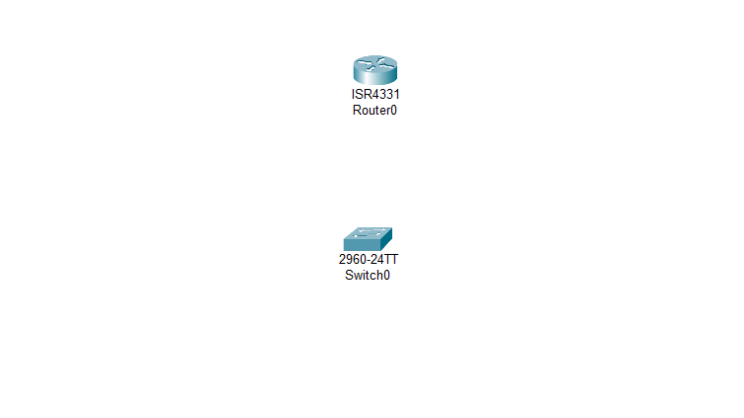

**Step – 2 :-**  We are having three departments therefore we are taking one pc , printer and access point for all the department.

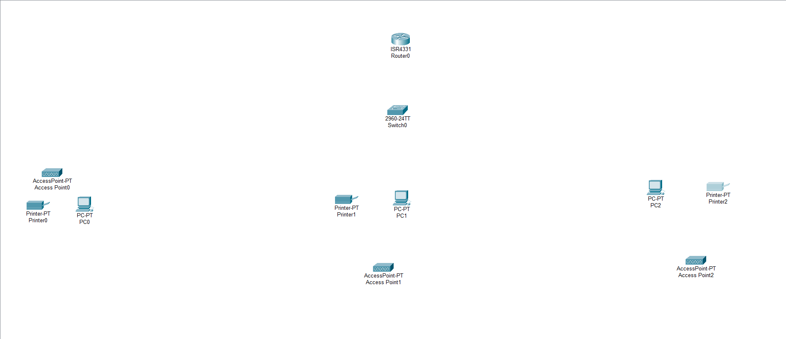

**Step – 3 :-**  Now Connect the devices using copper straight through cable.

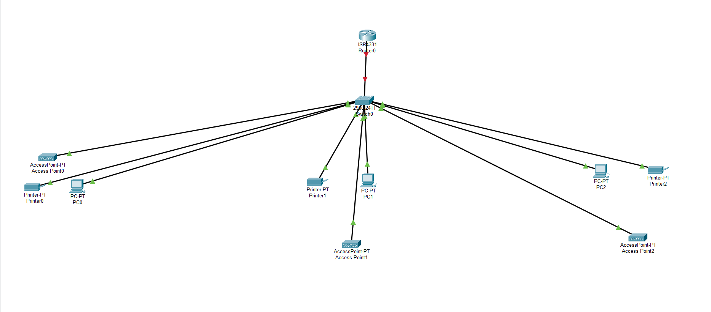

**Step – 4 :-**  Now Configure the Tablets Wireless SSID to HomeGateway.

Now we will create three VLAN for every department

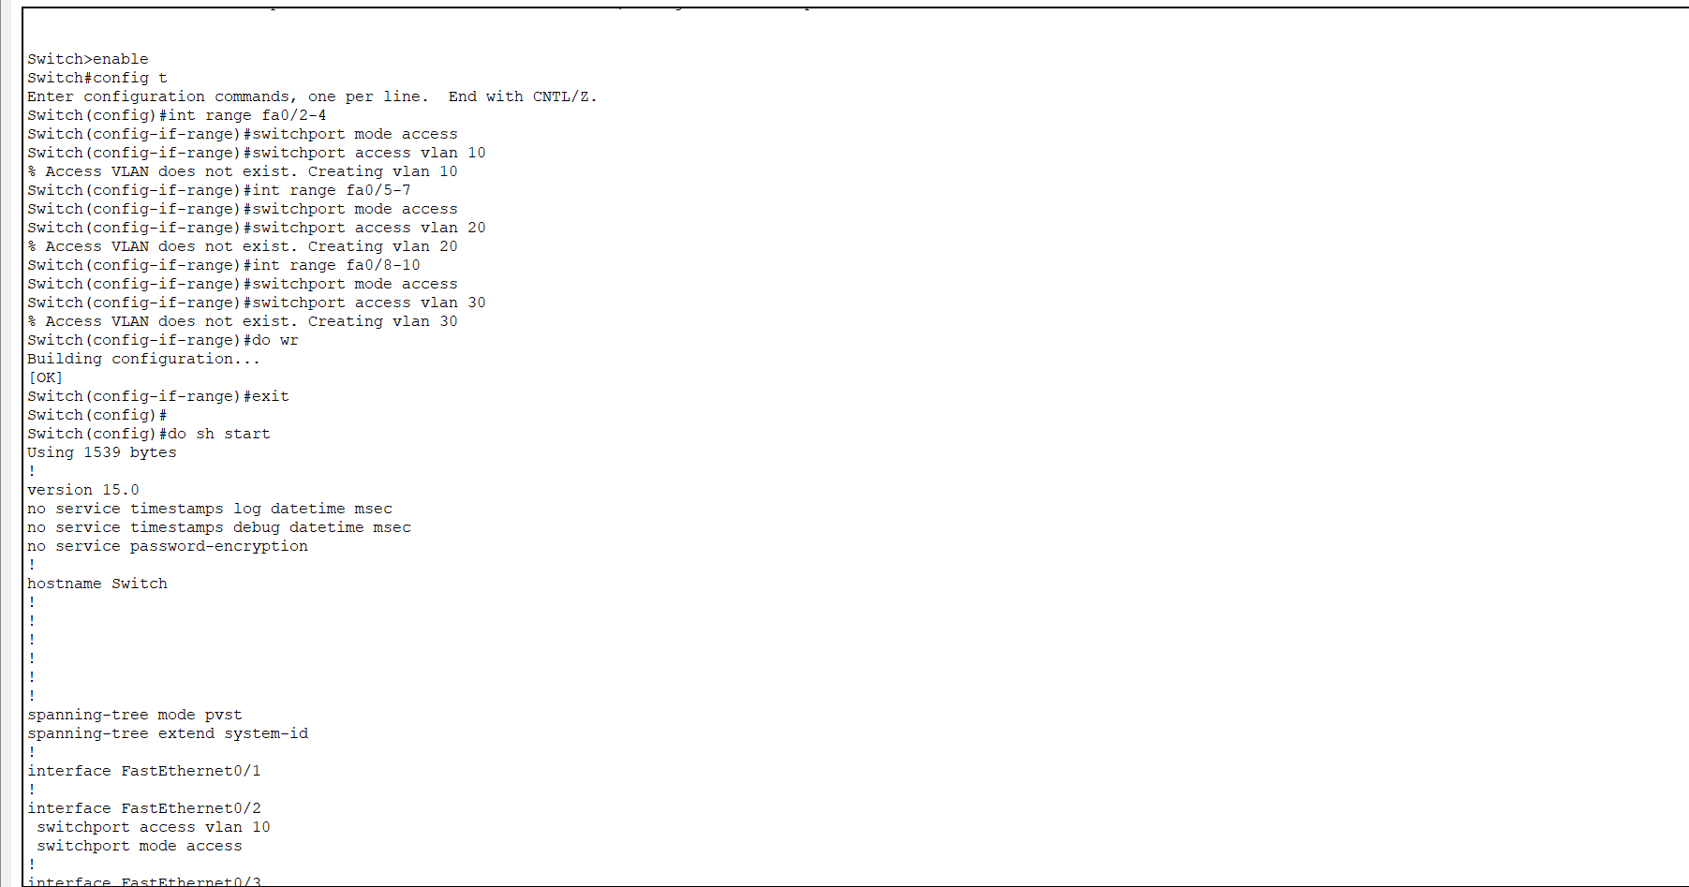

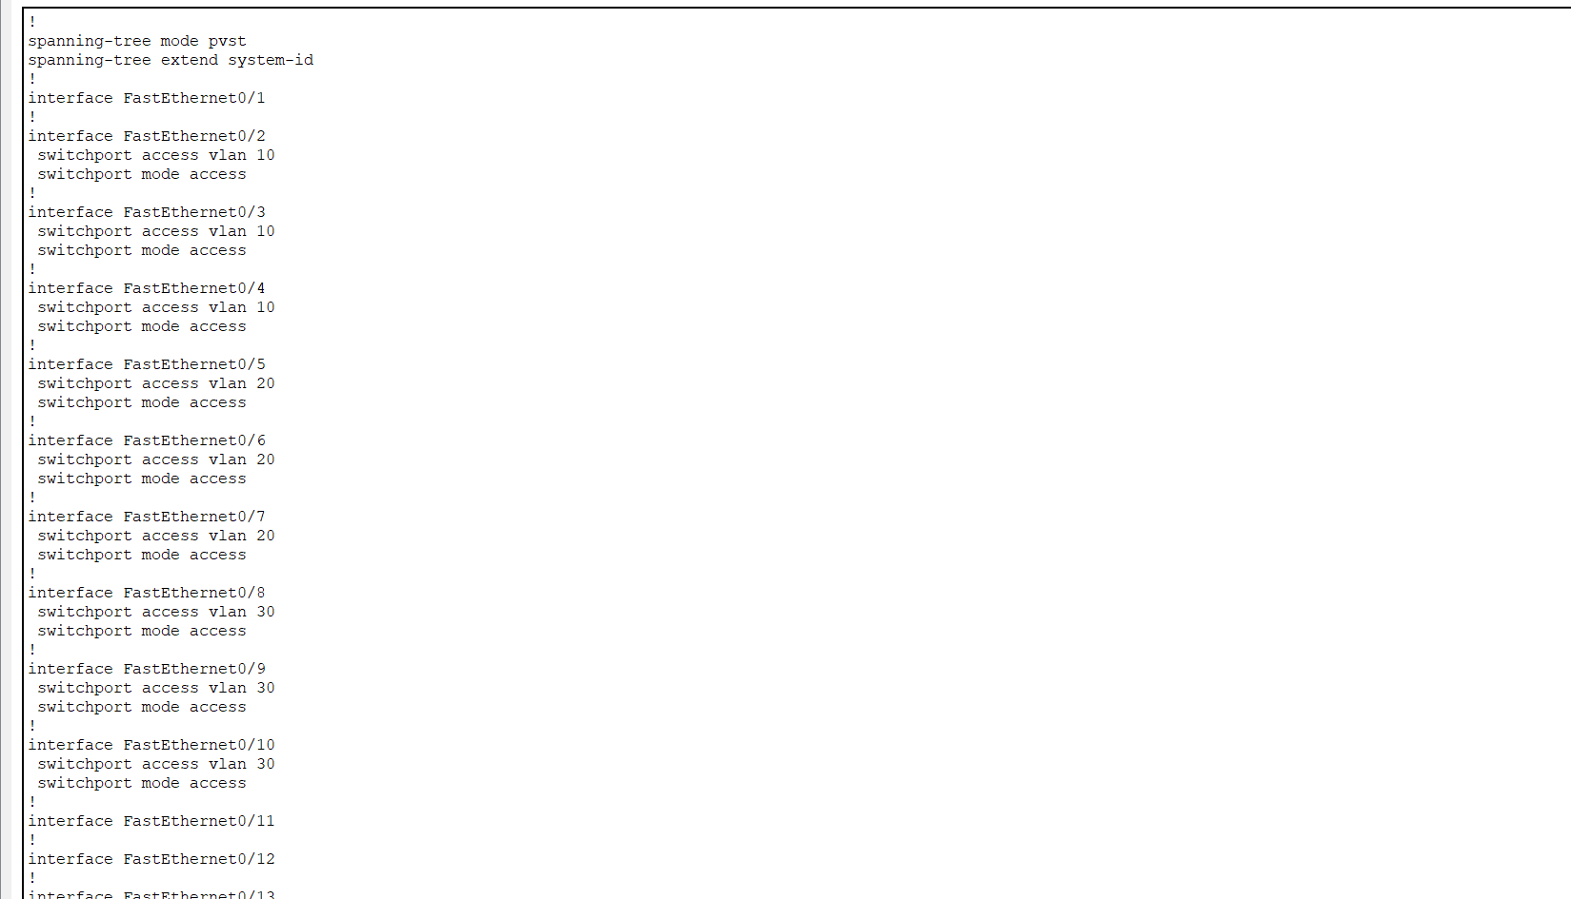

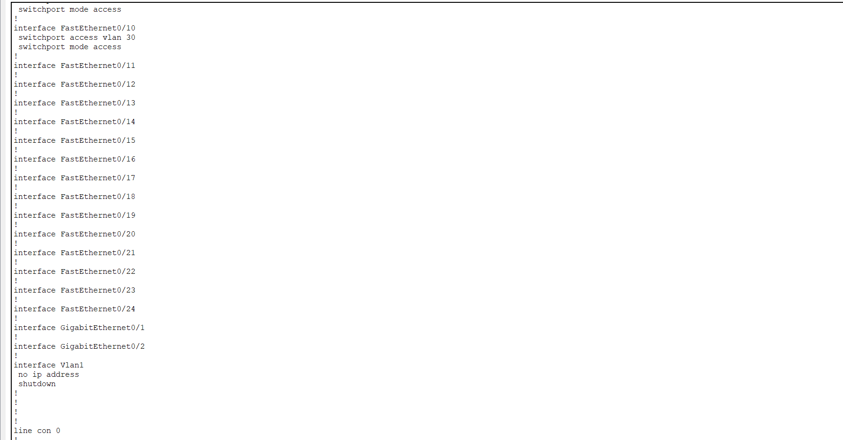

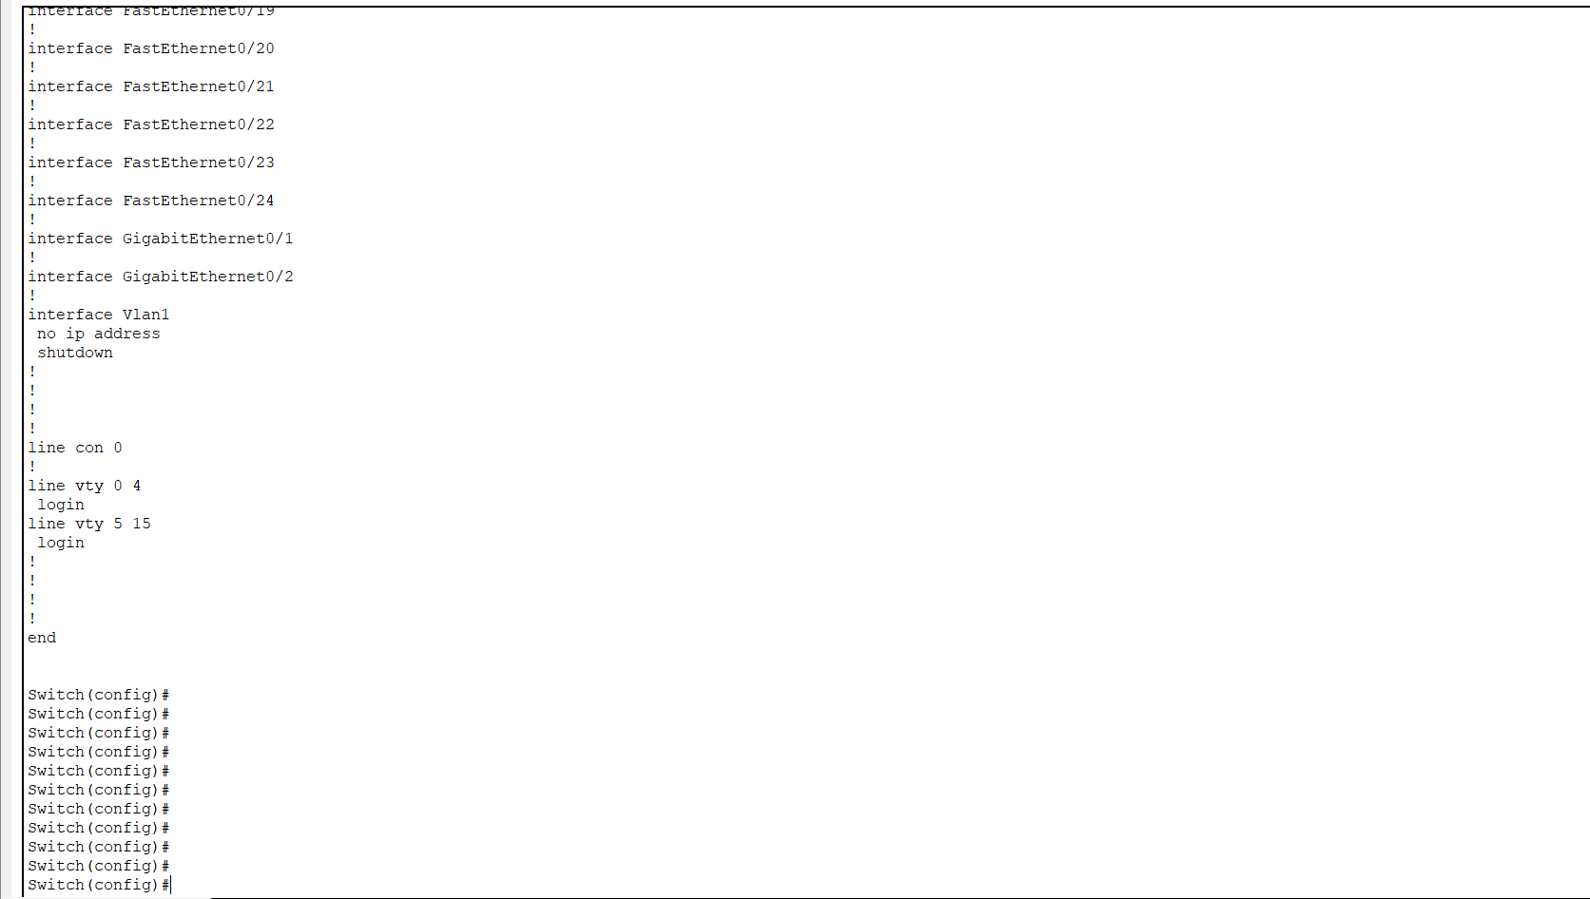

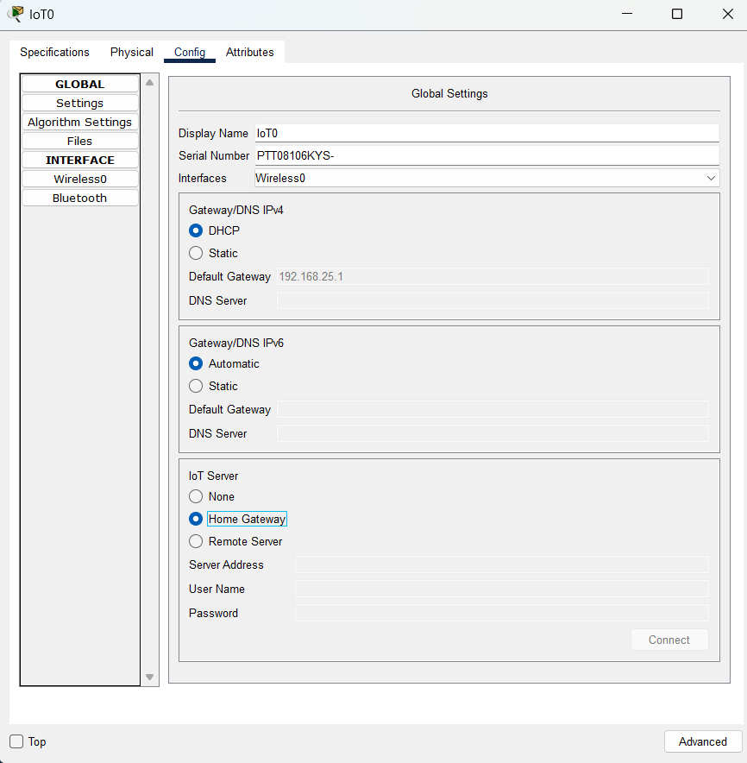**Step – 5 :-**  Now we will Register all the devices on HomeGateway.for that go to device>config > Iot Services > Choose HomeGateway

**Step – 7:-**  Now we will configure Access Point

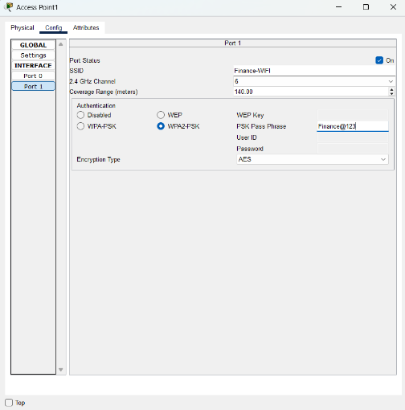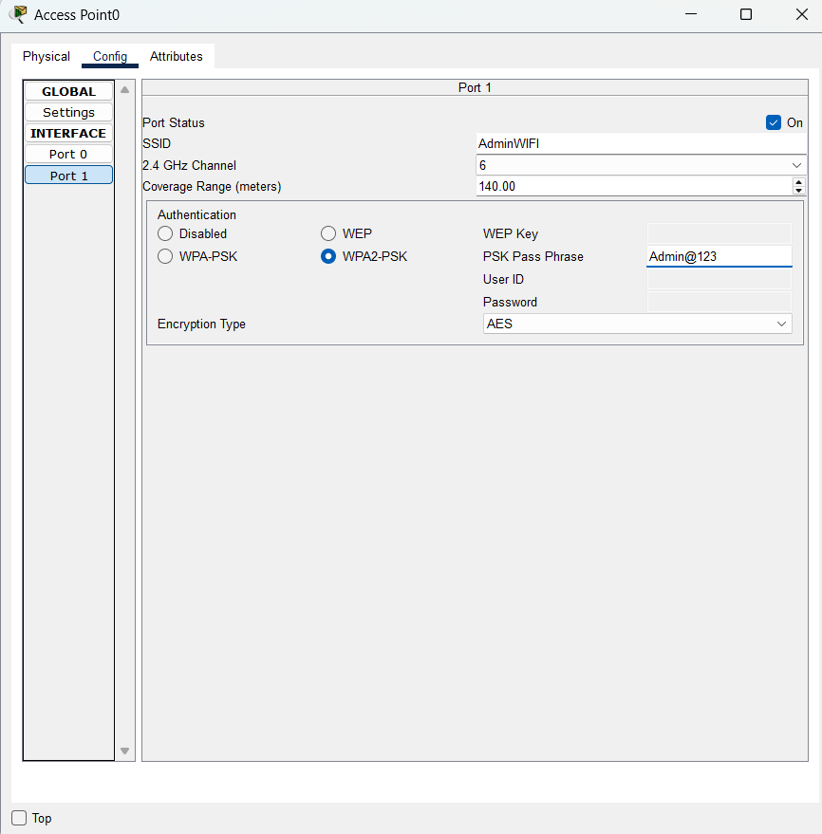

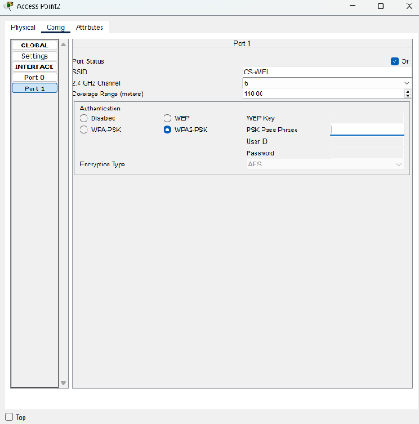

**Conclusion:-**

By Performing this Experiment I Learnt How the actual small size office network is configured.how the difeerent departments assigned different VLAN and how the network is designed , subnet mask is calculated . access points assigned passowerd.and it also help me gained a understanding of network design and engineering. This help me gain a deeper understanding and apply pratical concepts with the help of pratical scenario.